Output

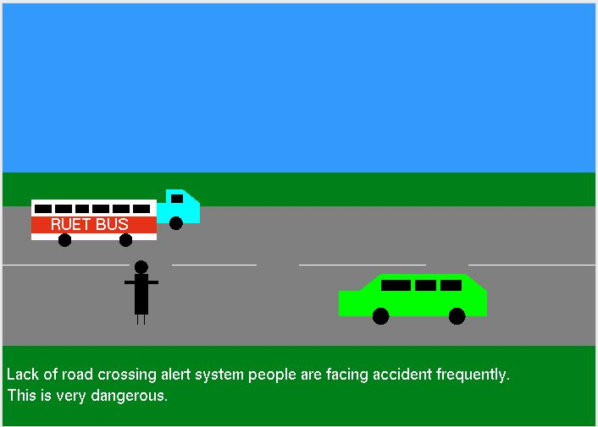This animation shows road accident prevention for busy road by latest technology.

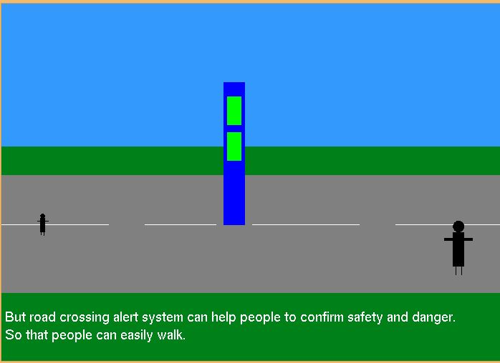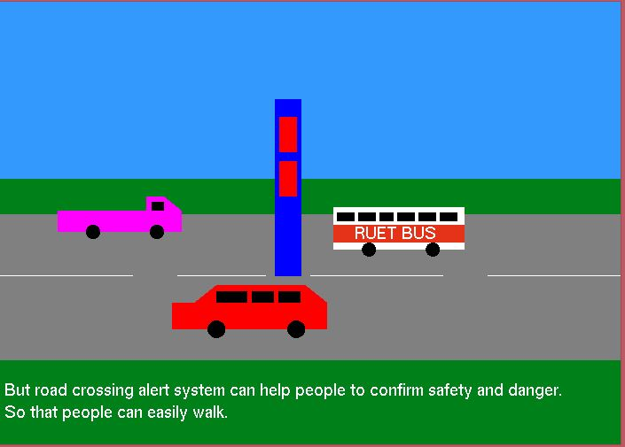I have proposed a road crossing alert system that will give signal for only people. So that when there is red signal, it will be risky to cross road but when there is green signal people can cross the road.

Object detection, Distance measure etc latest technologies are implemented in this system. So that it can work in complex lane too.

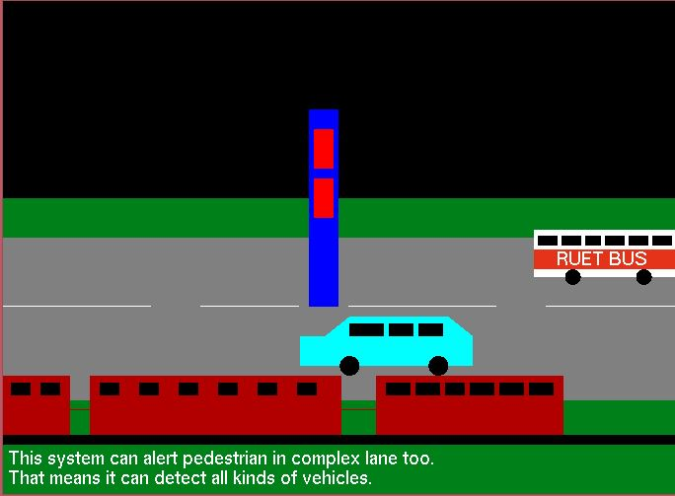

That’s it. The animation is about 2.5 minutes. I have showed both day and night scenario. Finally, this animation teaches us that it is possible to reduce road accident by applying latest technologies.